**Micro Chat**

**Introduction**

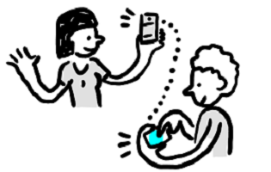

Use the **radio** to send and receive messages with other micro:bit.

**Set a radio group**

The first thing you want to do is to put in a set group. This will make certain that you and another micro:bit will receive just the messages assigned to that group and not the messages sent from some other micro:bit that’s not part of your conversation. This like tuning to a particular channel to talk on.

**Sending a message**

Use on button pressed to send a text message over radio with send string. Every micro:bit nearby will receive this message.

**Receiving a message**

Add a on received string block to run when a message is received

**Displaying text**

Add a show string to display the string on the screen. Pull the receivedString out of on received string and put it into show string.

**Testing in the simulator**

Press button **A** on the simulator, you will notice that a second micro:bit appears (if your screen is too small, the simulator might decide not to show it). Try pressing **A** again and notice that the “:)” message gets displayed on the other micro:bit.

**Try it for real**

If you have two micro:bits, download the program to each one. Press button **A** on one and see if the other gets a message.